Position Statement: Assessing Spatial Visualization Skills (Alisa Rod)

When designing or teaching GIS/mapping, whether in the form of supplemental workshops or as part of the curriculum of a course, it is necessary to assess and evaluate the extent to which the instructional content is informed by specific learning goals and the extent to which learning goals are achieved. This research project argues that spatial visualization skills rely on three distinct components: empirical reasoning, critical thinking, and design proficiency. This research project involves the development, testing, implementation, and standardization of an assessment tool for the purpose of evaluating the following spatial visualization-related learning goals, specifically in a liberal arts context:
- Apply principles of layout and visual design while avoiding misrepresentation
- Create accurate digital maps/spatial visualizations using GIS software
- Critically analyze visualizations and propose improvements
- Acquire critical skills of empirical reasoning/quantitative literacy

Current Status of Research Project

Thus far, I’ve worked to develop a pilot version of an assessment tool, which was administered as a pre- and post- test in 3 courses during spring 2019 (n = 40 students for the pre-test, n = 18). Each of these courses relied on supplemental GIS workshops developed and taught by the Empirical Reasoning Center (ERC), an instructional support service within the Barnard College Library. The assessment tool also includes the Subjective Numeracy Scale (SNS), which is a validated measure of an individual’s confidence with numerical information (Fagerlin et al., 2007). The SNS also correlates with objective numeracy measures, meaning it can be used to approximate and/or predict numeracy ability. Over the summer of 2019, an ERC staff member and an intern, both of whom have taken at least one GIS methods course, developed a grading rubric with 3 categories (not proficient, proficient, highly proficient) for the assessment and coded all of the open-ended responses. I am in the process of analyzing the coded responses, though it became clear during the development of the rubric that the assessment tool will need revisions before the full-scale implementation in fall 2019. For example, the coders had to recode 3 samples before reaching an acceptable inter-rater reliability score.

See below for an example question from the assessment tool:
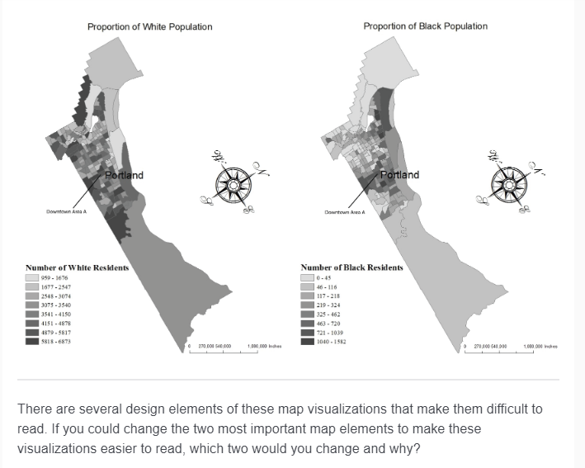

We are currently in the process of reviewing the items with initial high disagreement between coders to adjust the question and/or update the rubric with more explicit cut points. Another issue is that the administration of the post-test was done too hastily and the course instructors were more hesitant to allow enough class time to complete the assessment, resulting in an unacceptable drop-off rate. Thus, we will unfortunately not be able to perform much analysis looking at the change between pre and post for the pilot.

Next steps

After we update the assessment tool and grading rubric, we will implement the pre and post version of the assessment in the fall and spring semesters of the 2019-2020 academic year. In the fall, I will teach the Introduction to GIS Methods course for the urban studies department, and will require that students participate in the assessment for participation points. The GIS methods student sample will allow us to create a standardized version of the tool. In the spring, we will implement the assessment in courses for which we are offering only supplemental mapping workshops (between 2 and 5 workshops total depending on the course), which will allow us to compare the change in proficiency of map literacy within a course dedicated to GIS vs. courses that rely just on supplemental instruction. This will have implications for the use of a standardized assessment tool to more broadly evaluate library instruction regarding supplemental training in spatial visualization. In addition, we aim to define and outline the scope of learning outcomes of supplemental spatial visualization instruction (e.g. providing an answer to the following question: to what extent can we expect students to become proficient in at least some facets of map literacy over the course of supplemental instruction alone?).

Works cited

A. Fagerlin, B.J. Zikmund-Fisher, P.A. Ubel, A. Jankovic, H.A. Derry, & D.M. Smith (2007) Measuring numeracy without a math test: Development of the Subjective Numeracy Scale (SNS), Medical Decision Making, 27: 672-680

